Robotic Motion Phantom

Getting Started Guide

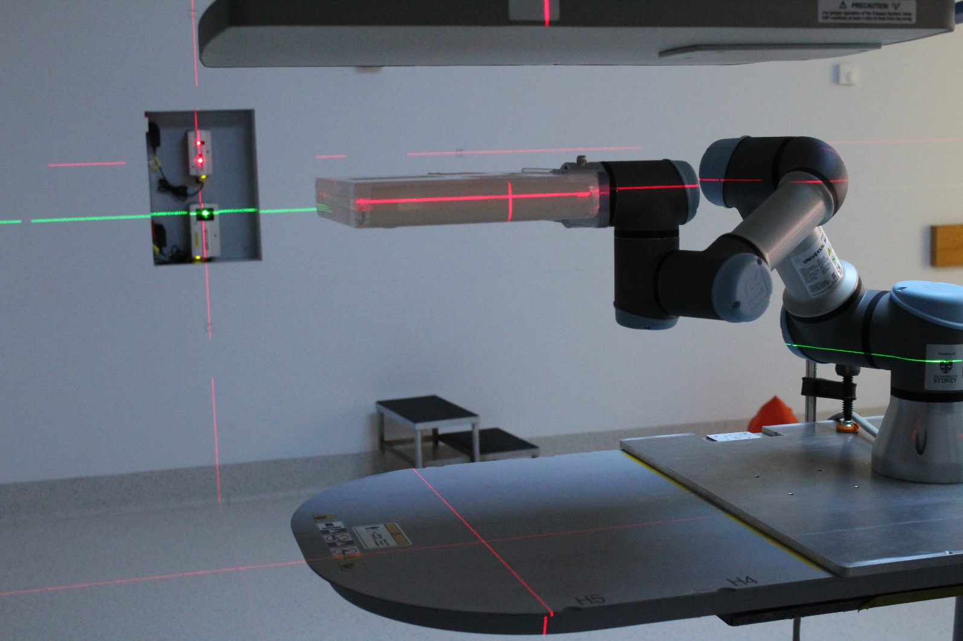

**Coordinate System of Robotic Motion Phantom**

The coordinate system of the robotic motion phantom is based on the *IEC 61217 Radiotherapy equipment – Coordinates, movements and scales*. The figure below depicts the coordinate system of the robotic motion phantom. All input motion traces should be placed in this reference frame.

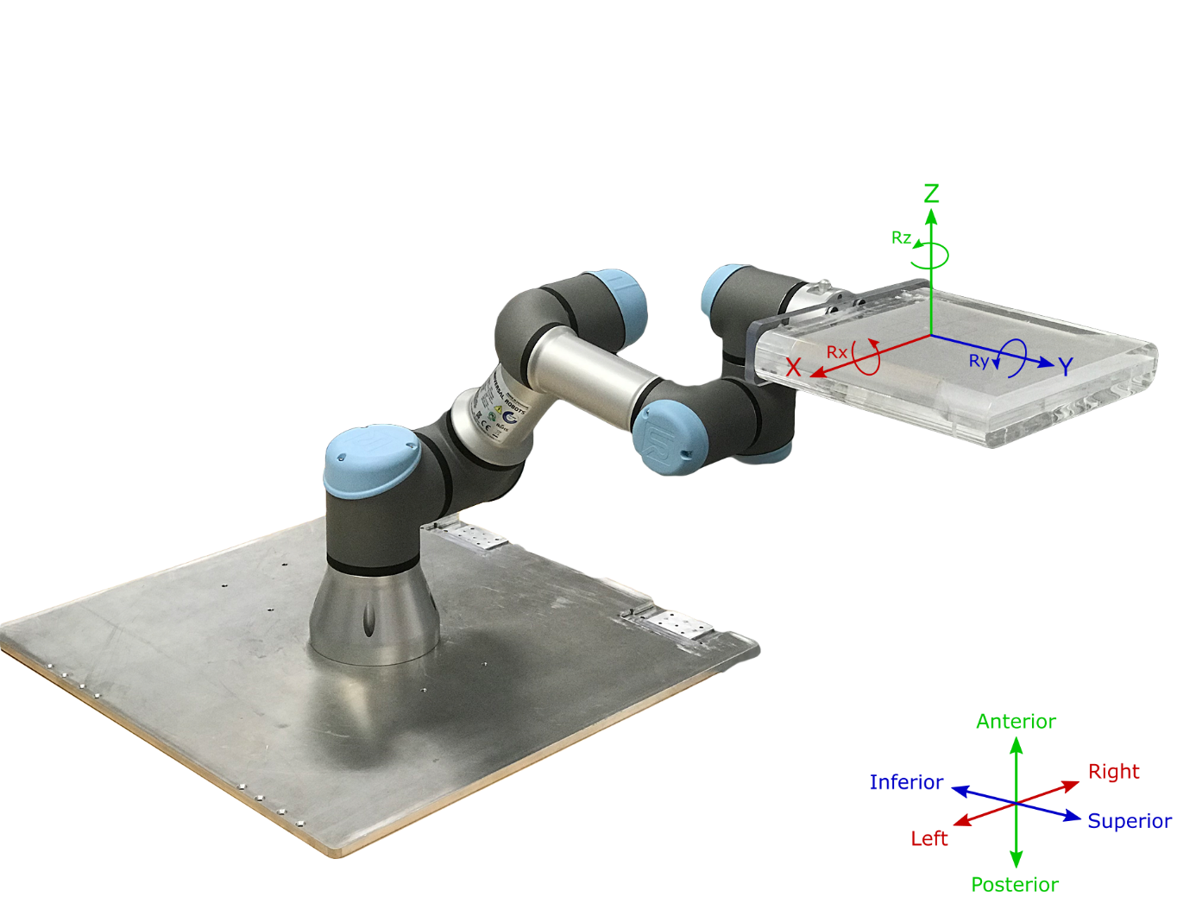

Please note: When using the tablet to control the robotic arm, the coordinate systems shown on the tablet will be different to the clinical coordinate system used in the motion software. Below shows the Base () and tool () coordinate system of the robotic arm when using the tablet.

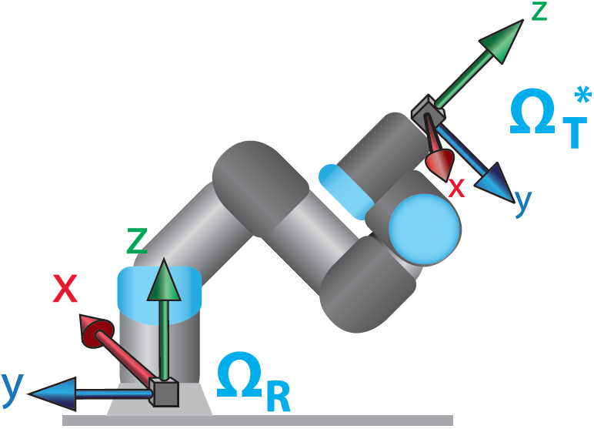

**Setting up Robotic Motion Phantom**

1. Mount robot to base plate using the 4 M6 screws.

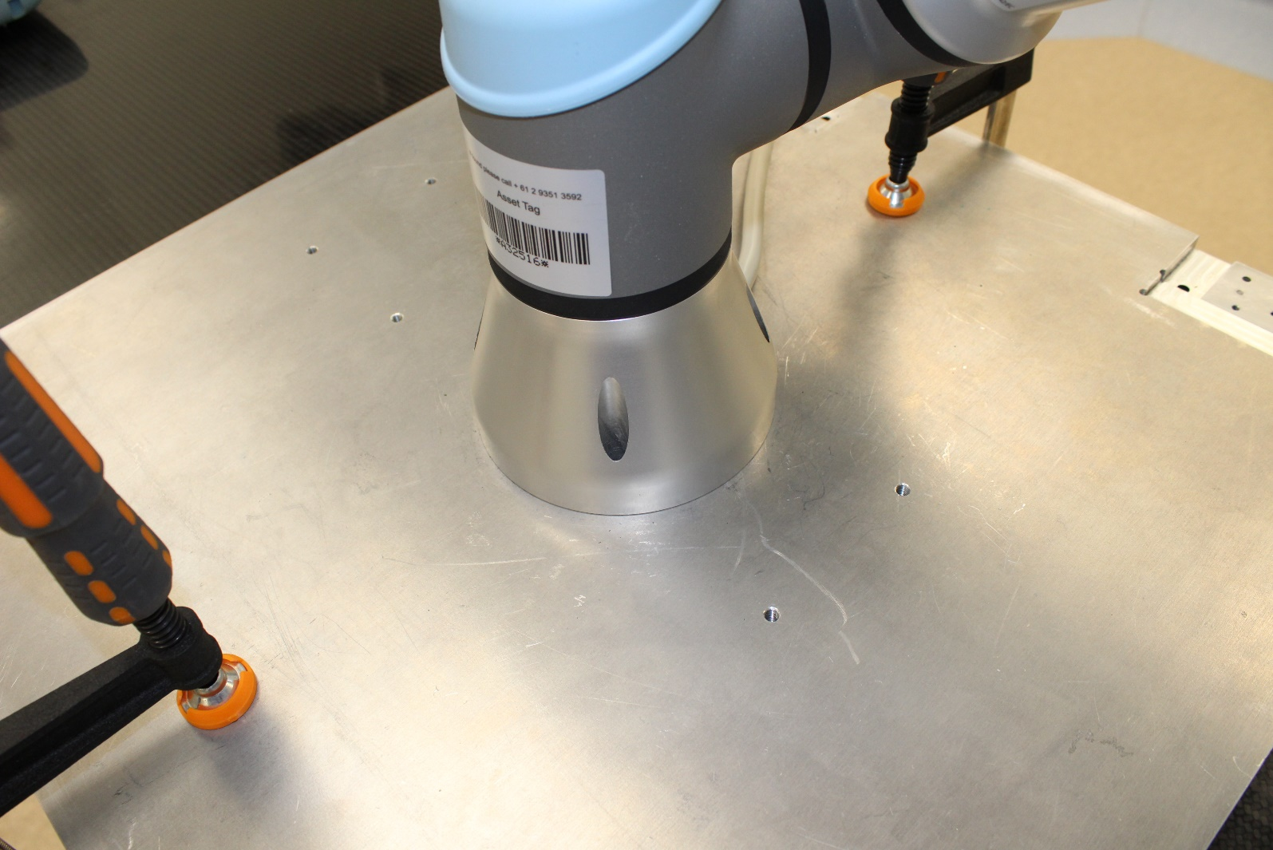

1. Mount gripper plate to tool flange, then attach phantom to gripper plate using the provided screws.

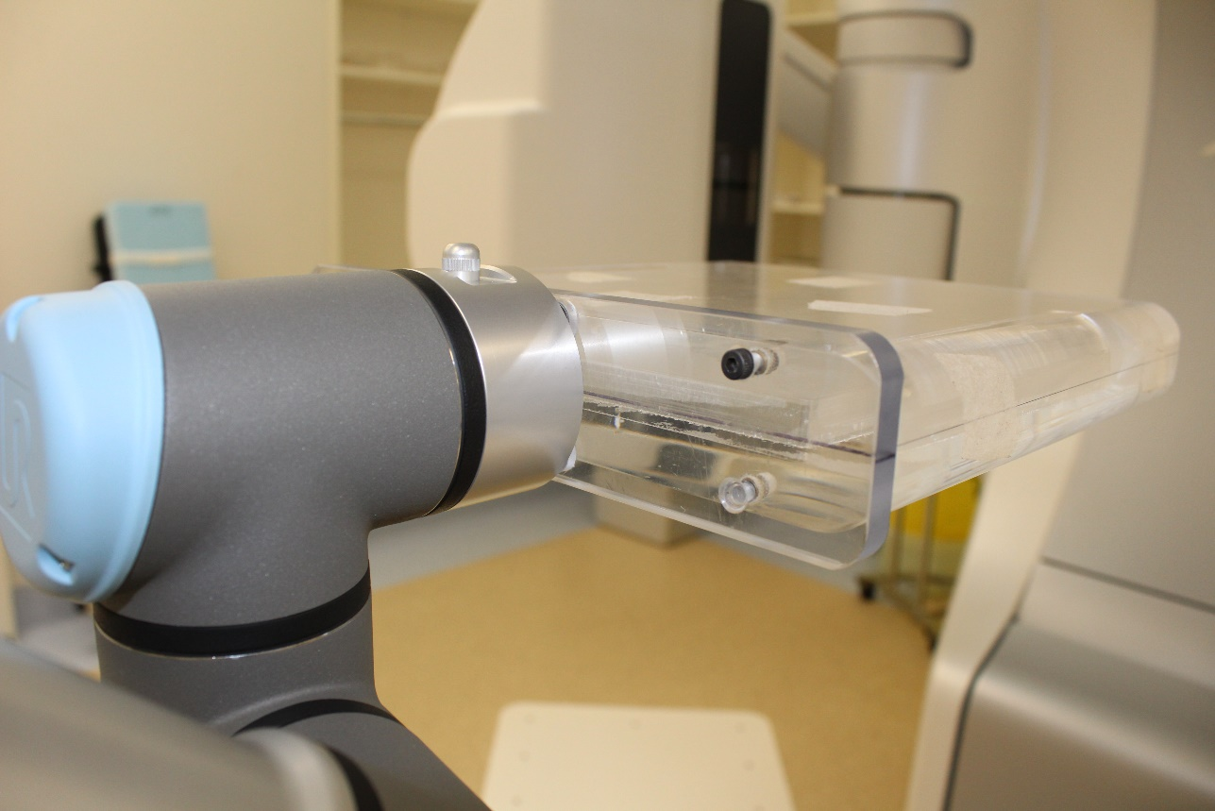

**Positioning Robotic Motion Phantom**

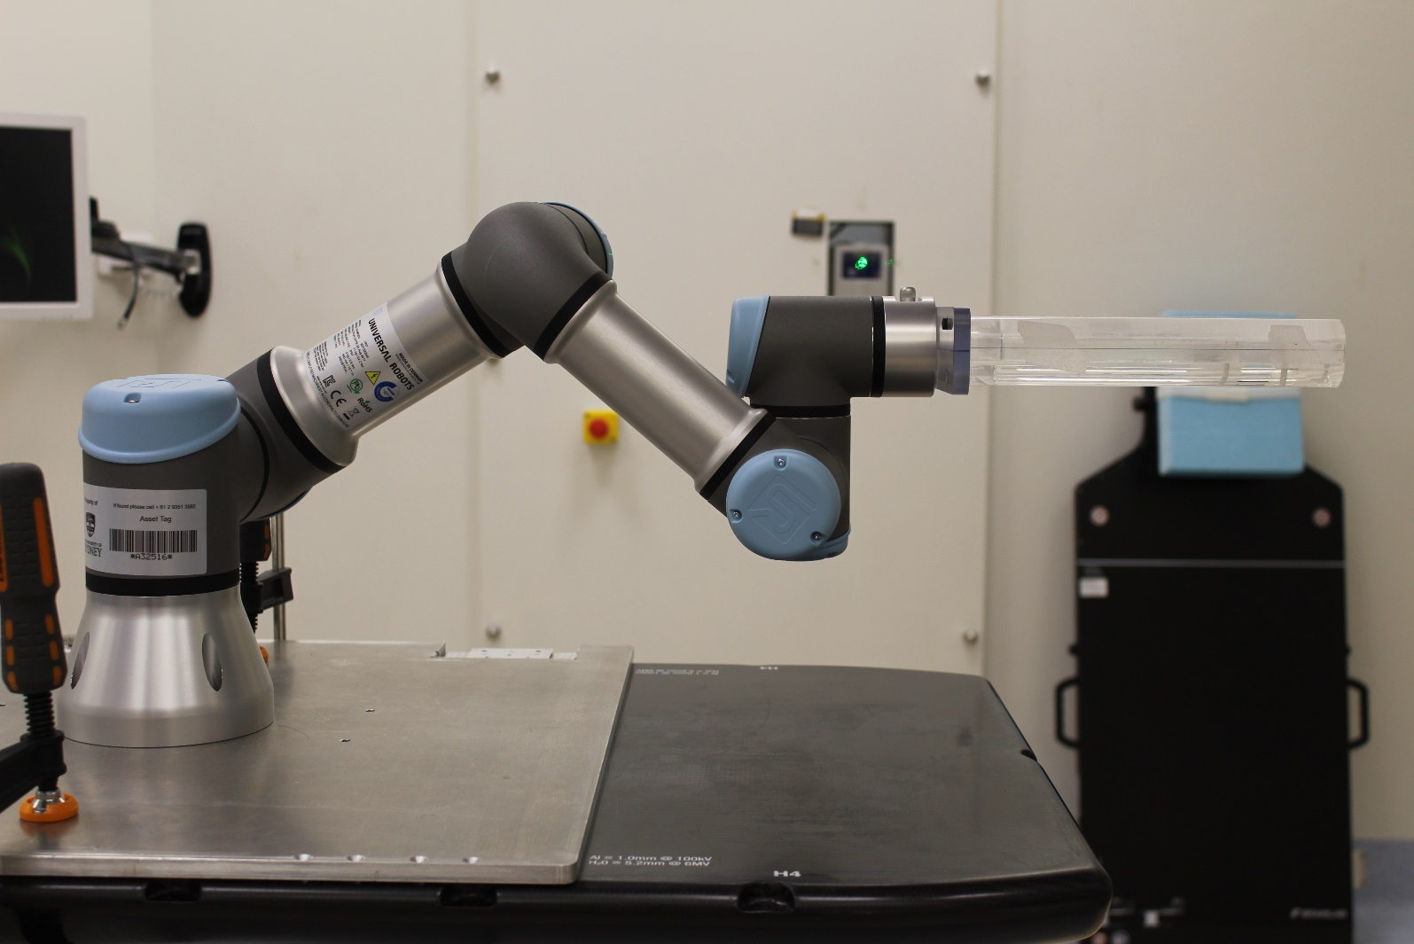

Can be moved futher

towards shoulder

Elbow down

Shoulder up

The figure above shows the most optimal position to use the robotic motion phantom when running motion traces. Placing the shoulder up and the elbow down allows adequate flexibility and range of motion. The Elbow joint can even be moved further down and closer to the shoulder if needed for even more range of motion. To move the robot, hold the free drive button on the tablet. **Important: If the phantom is attached you will need to support the phantom before pressing the free drive button. Failure to do so will cause the phantom to drop and collide with the couch.**

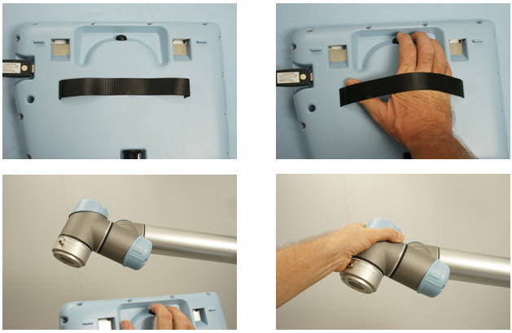

Freedrive button

**Connecting to the Robot**

Once the Ethernet cable is connected between the PC and the Robotic Controller, the IP address needs to be configured on the robot, software and PC.

**PC:**

Go to *Control Panel* Under the *Network and Internet settings* 🡪 *Network Connections* 🡪 *Ethernet.* Right click *Ethernet* and then click *Properties*. Select *Internet Protocol Version 4 (TCP/IPv4)* and then click *Properties.* Setup the IP address and subnet mask.

* IP address
* Subnet mask

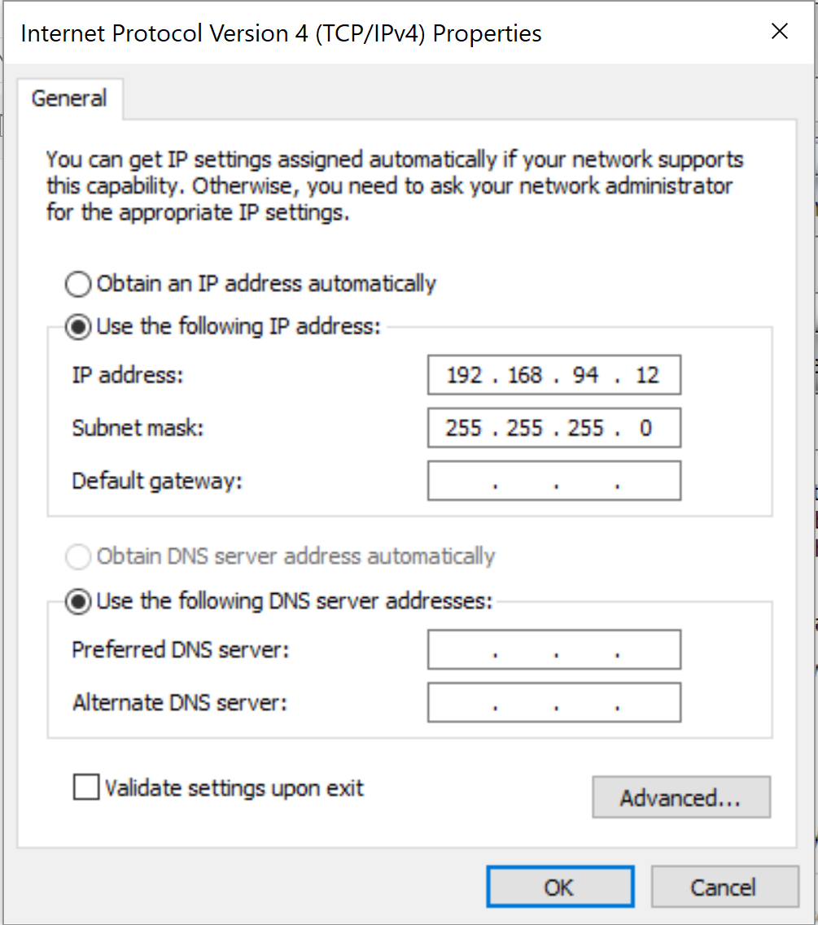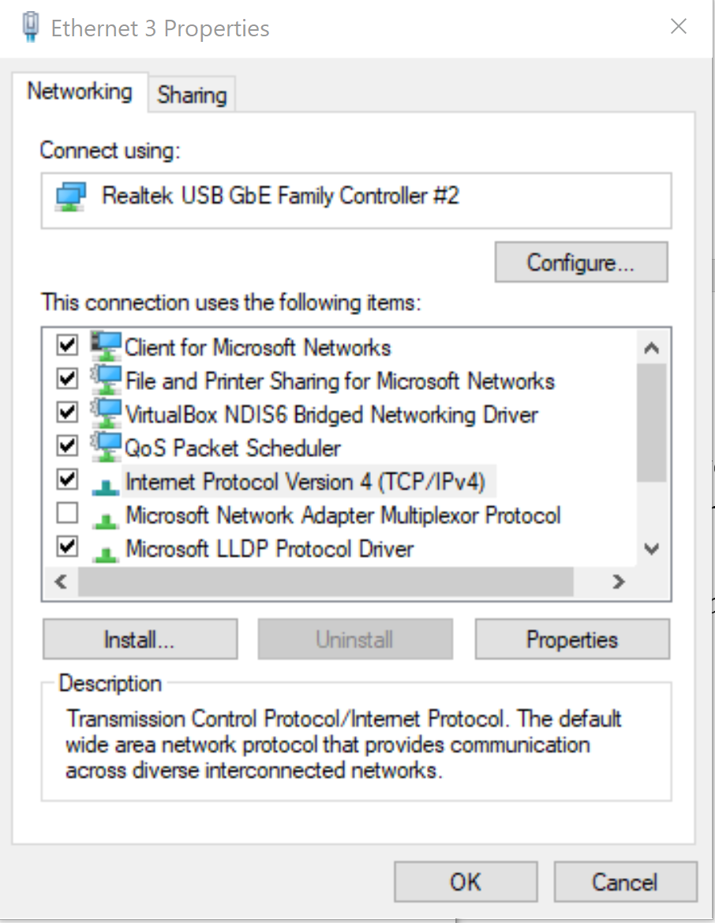

The IP address on the robot and PC should be the same apart from the last number. In this case: 192.168.94.x, both subnet masks should be 255.255.255.0.

**Robot:**

Go to the *Setup Robot*, and select *Setup Network*. The setup:

* IP Address
* Subnet mask

The IP address should be in the same format as the PC: 192.168.94.x, and the subnet mask should be 255.255.255.0

192.168.94.11

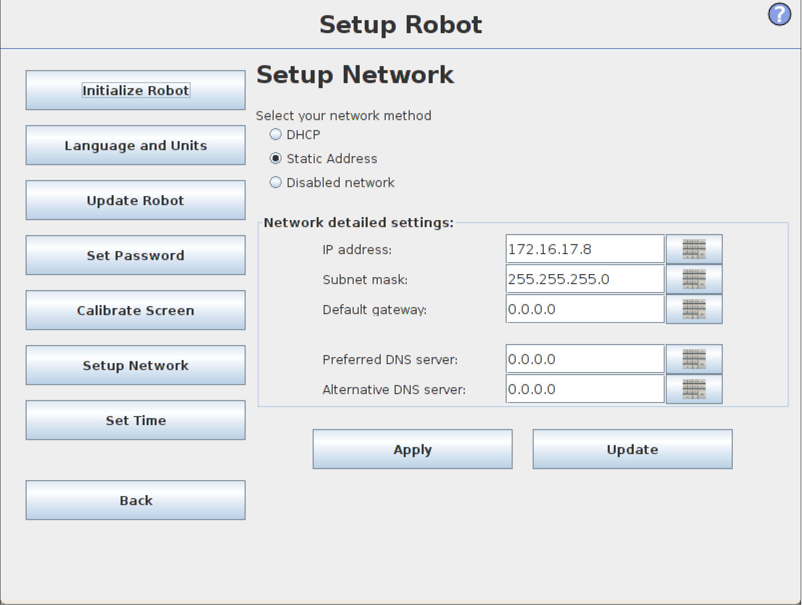

**Software:**

Under the *Settings* 🡪 *Connection*, enter the IP address of the robot, in this case 192.168.94.11. See *Software GUI Guide*.

**Setting Origin of Motion**

To move the origin of motion to the treatment isocentre, enter the x, y and z distances from the centre of the tool flange of the robot arm to the desired point on the phantom. **The z coordinate needs to be reversed as compared to IEC coordinate system/what’s shown below. So, positive z is towards posterior direction (only in the default of origin of motion coordinate system). Everything else follows IEC.**

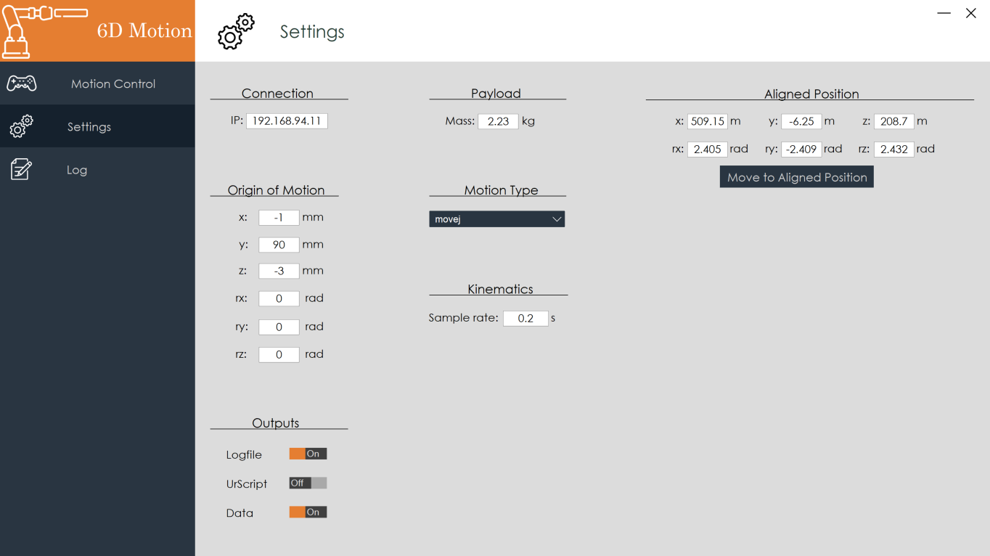

Figure below shows the default origin of motion:

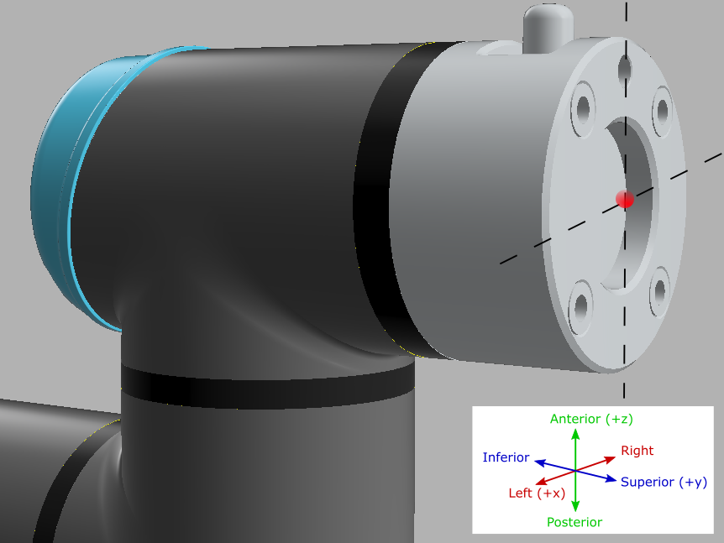

**Setting Aligned Position**

Once the robotic phantom is aligned to the treatment isocentre, the user may record the 6DoF position from the tablet of the robot in the *Base coordinate system*. These values can be inserted in the setings.txt file, this will allow the values to automatically be loaded each time the software is run. Click *Move to Aligned Position* button to move the robotic phantom to the inputted position. Please note, if the robot is starting from the home position it will not be able to move to the aligned position. To overcome this, use the free drive mode to move the robot out of the home position first. The aligned position will move assuming the origin of motion is set as [0,0,0,0,0,0].



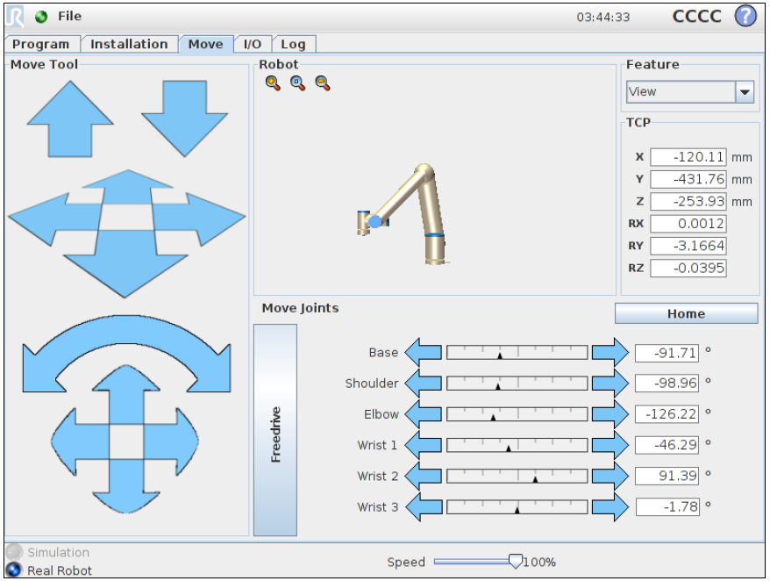

Once aligned, record these values and input into software settings.txt file.

Make sure this is set to Base before you record the aligned position.

**When Packing Up**

When the robot is no longer in use, remove the attached phantom and send the robot to the home position via the tablet.



